

JKKI: Jurnal Kedokteran dan Kesehatan Indonesia
Indonesian Journal of Medicine and Health
Journal homepage: https://journal.uii.ac.id/JKKI
P-ISSN 2085-4145 | E-ISSN 2527-2950
Title of the article, written in Cambria font, size 14, bold, single-spaced, maximum 20 words: Subtitle can be used to explain a long title, avoid non-standard abbreviations
First Author,*¹ Second Author,² Third Author²
¹Department of X, Faculty of Y, University of Z, Province, Country
²Department of A, Hospital B, Province, Country
Article Info: | Article History:
Keywords: keyword 1; keyword 2; keyword 3; keyword 4; keyword 5 | Received:  Accepted:  Online:
*Corresponding author:  email@email.ac.id | DOI:
Original Article

ABSTRACT
Background: Abstract contains about 150-300 words and should be an objective representation of the article. Use a structured abstract containing background, objectives, methods, results, and conclusions. The background consists of a maximum of three sentences and places the question addressed in a broad context.
Objectives: This part must state clearly the objective(s) of this current study or investigation.
Methods: This part must describe briefly the main methods (selection of study subjects or laboratory animals; observational and analytical methods), measurement methods and their analysis if possible. The methods should be written in past tense.
Results: This part summarizes the main results (giving specific data and their statistical significance, if possible); and it should emphasize new and important aspects of the study or observations. Then it must not contain results which are not presented in the main text.
Conclusion: This part states the principal conclusions or interpretations.

INTRODUCTION
The introduction should briefly place the study in a broad context and highlight why it is important. It should be written clearly comprising general background, state of the art, novelty and originality (compared to previous literatures and providing references as original research articles within 10 years), problems and hypotheses (if any), purposed problem solving (if any). In the text, the citation can be written at the end of the sentences using the Vancouver style.¹ It should define the purpose of the study and its significance. The current state of its research field should be reviewed carefully, and key publications should be cited.
The authors also must highlight controversial and diverging hypotheses when necessary. As far as possible, the introduction should be comprehensible to scholars outside their field of research.²⁻⁴ This section should be written without subtitles and contain background information such as prior work and the objectives of study. It also should describe the rationale of the study (need and significance). The authors should summarise the previous relevant research and explain their findings (pro and contra results). Also, they must describe the novelty and the objective of their study.⁵
The authors can be also stated in the text, for example a study by Sulistyoningrum et al. (2015) stated that introduction is recommended to be written in 3-5 paragraphs length neither too long nor too short.6 Also they must state the contribution of their current research to the health and medicine development in Indonesia, and emphasize its importance to Indonesia. Finally, they must briefly mention the main purposes of their study and preferably highlight some principal conclusions.

METHODS
This section should be described with sufficient details to allow others to replicate and build on published results.

Study design
This part describes clearly the research design, including more specific designs if any. The authors also must state the time and location of the study. Please use recommended guidelines to report any specific research design at https://www.equator-network.org/.⁷

Population and sample
This part demonstrates the population and the sample used in the study. Please note that publication of the manuscript implicates that it must make all materials, data, and protocols associated with the publication available to readers. Any method to select study subjects, selection of subjects or study sample, and sample size determination should be described clearly, including the formula for sample size determination and sampling techniques.

Data collection
The authors must disclose at the submission stage any restrictions on the availability of materials or information. New methods and protocols should be described in details, while well-established methods can be briefly described and appropriately cited.⁸ Research manuscripts reporting large datasets that are deposited in a publicly available database should specify where the data have been deposited and provide relevant accession numbers. If the accession numbers have not yet been obtained at the time of submission, the authors must state that they will be provided during review stages. They must be provided prior to publication. Measurements of length, height, weight, and volume should be reported in metric units (meter, kilogram, or liter) or their decimal multiples. Temperatures should be in degrees Celsius. Blood pressures should be in millimetres of mercury unless other units are specifically required by the journal. In manuscripts that report on randomized clinical trials, the authors may provide a flow diagram in CONSORT format, including all of the information required by the CONSORT checklist.

Data analysis
Any software used in data analysis must be stated clearly. The authors must mention the statistical analysis used in the study. Also, they must state the confidence interval used in the study. In general, statistical values should be reported to three decimal places (example given: p<0.001).

Ethical statement
For all manuscripts, reporting data from studies involving human participants or animals, formal review and approval or formal review and waiver, by an appropriate institutional review board or ethics committee or other related institutions, are required and should be described in this subsection (include also the number of ethical approvals). In studies involving humans, the authors should describe how consent was obtained from participants.

RESULTS
This section should provide a concise and precise description of the experimental results. It should provide a concise and precise description of the experimental results and their interpretation. Result can’t contain any references. It may be divided by subheadings as illustrated below.
Subtitles
The results should be equipped with tables and figures. The maximum cumulative number of tables and/or figures is 6 in 1 manuscript. Tables and figure insertion must be set efficiently without duplication. One result only needs to be presented in one presentation from either figure or table, but not both. Tables and figures must be titled; both titles should be aligned left and suitable for the images and tables. Any abbreviations written in the tables or figures must be explained below the tables and figures.

Tables
The tables should be numbered in the text sequentially, written in single-space with Cambria size 10 (Table 1). The table title should be precise, clear, and located above the table. Please do not use internal horizontal or vertical lines; the border is only used in the column headings and the end of the tables. The tables must be placed after they were discussed in the text.
Table 1. Reporting guidelines to report main study types
Study types | Recommended reporting guidelines | Useful links
Randomised trials | Consolidated Standards of Reporting Trials or CONSORT | https://www.equator-network.org/reporting-guidelines/consort/
Observational studies | STrengthening the Reporting of OBservational studies in Epidemiology or STROBE | https://www.strobe-statement.org/
Diagnostic/prognostic studies | Standards for Reporting of Diagnostic Accuracy (STARD) | doi: 10.1007/s11606-008-0583-3
Diagnostic/prognostic studies | APPRAISAL OF GUIDELINES FOR RESEARCH & EVALUATION II (AGREE II) | doi: https://doi.org/10.1136/bmj.i2027
Qualitative research | Standards for Reporting Qualitative Research (SRQR) or  Consolidated criteria for reporting  qualitative research (COREQ) | 0.1093/intqhc/mzm042  DOI: 10.1097/ACM.0000000000000388
Animal pre-clinical studies | ARRIVE (Animal  Research: Reporting of In Vivo Experiments) | DOI: 10.1371/journal.pbio.3000410

The authors should place explanatory matter in footnotes, not in the heading. If the tables contain numbers, please use (.) to separates decimals (limited to only 2 decimals). Any statistical values should be written in 3 decimals. Any symbols must be placed properly and described in the caption (Table 2).

Table 2. Elements of benefits of implementing MSS health in Lumajang Regency
Compound name | Assay/method |  | Targeted DENV serotype and cell line used | Study parameters
Quercetin⁵³ | MTT assay, RT-PCR, molecular docking | DENV-2 strain NGC, Huh7it-1 |  | - IC₅₀= 1.1 μg/ml  - CC₅₀= 38.8 μg/ml  - SI= 38
Isobutyl gallate⁵⁴ | MTT assay, FAA | DENV-2 strain New Guinea C (NGC), Huh7 it-1 |  | - CC₅₀= 167.19 µg/mL  - IC₅₀= 4.45 µg/mL  - SI= 25.69
Curcumin⁴⁵ | MTT assay, plaque assay | - Virus: DENV­1 strain JMB­034, DENV­2 strain SUB­011, DENV­3 strain SUB­006, and DENV­4 strain SUB­007  - Cell line: alveolar epithelial carcinoma A549, fibroblast BHK­21 |  | - IC₅₀=20.60 µM (DENV-1); 13.95 µM (DENV-2); 25.54 µM (DENV-3); 12.35 µM (DENV-4)  - CC₅₀= 108 µM
6-gingerol⁴⁵ | MTT assay, plaque assay | - Virus: DENV­1 strain JMB­034, DENV­2 strain SUB­011, DENV­3 strain SUB­006, and DENV­4 strain SUB­007  - Cell line: alveolar epithelial carcinoma A549, fibroblast BHK­21 |  | - IC₅₀= 14.70 µM (DENV-1),14.17 µM (DENV-2), 78.76 µM (DENV-3), 112.84 µM (DENV-4)  - CC₅₀= 210 µM
MSS: Minimum Service Standards

Figures
Figures should be professionally drawn. photographed or submitted as high-quality digital prints. They also should be sequentially numbered and provide information related to their results that are presented in texts without duplication. Important points in the figures must be annotated and described in the caption or figure legend, which should be written in Cambria size 10. Histological pictures must be accompanied by the staining method and magnification (Figure 1).
Initial submissions do not require high-resolution image files, but images must be of sufficient resolution for reviewers to properly evaluate the data. It is suggested that they must be incorporated with the manuscript text into a single Word document at initial submission, but separated image files may be supplied if necessary. Should your manuscript be accepted, you will receive more extensive instructions for final submission of display items. However, some guidelines for the preparation of final figures are provided below if you wish to minimize subsequent revisions and potential delays. The images should be in RGB colour and at a resolution of 300 dpi or high. The authors should use the same typeface (Cambria) for all figures.

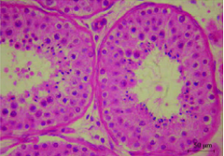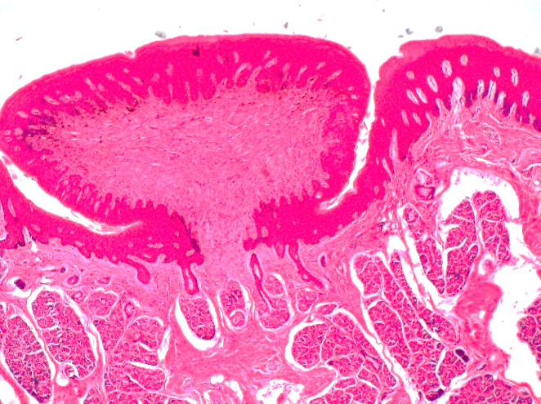
A
B

Figure 1. Some examples of histopathological pictures. A. tubuli seminiferi with germinal epithelium (red arrow), B. lingual papilla with von Ebner gland (black arrow). Haematoxylin-Eosin staining, 400X magnification

One figure can be explained as a maximum of four relevant figures. The title of the figures should be short and clear and located below the image. Important points in the figure must be annotated and described in the caption or figure legend, which should be written in Cambria size 10. Statistical figures should be equipped with axis titles (Figure 2).

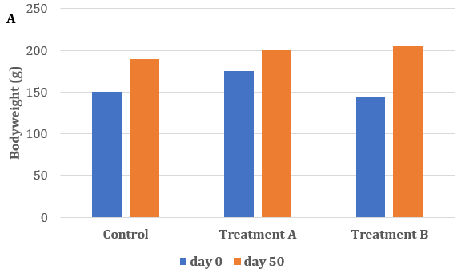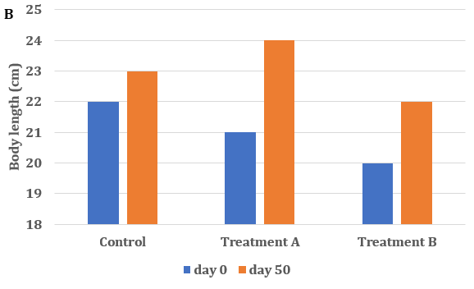
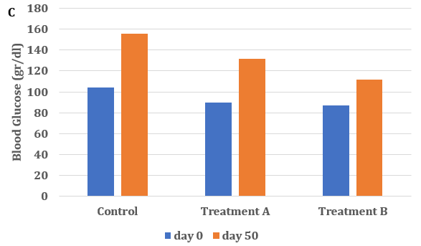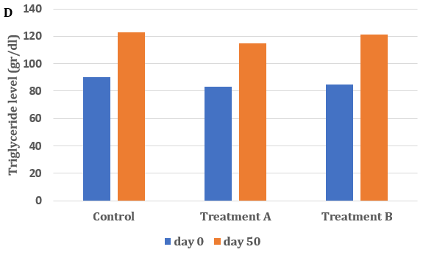
Figure 1. Comparison of anthropometric and biochemicals parameters among groups before and after treatment. A. Bodyweight, B. body length, C. Blood glucose level and D. triglyceride level

DISCUSSION
This section should not be divided by subheadings. It must summarise the major findings of the study and compare its results with previous research. The discussion also explains why the study obtains such results matching the findings, the mechanism of the results, and the reasons for the differences and similarities with previous research. Also, it needs to state limitations and implications of the study to the Sustainable Development Goals. The authors should discuss the results and how they can be interpreted from the perspective of previous studies and of the working hypotheses.
References used in this section should come from original studies reported on the same topics. The findings and their implications should be discussed in the broadest context. Limitations of the current study must be highlighted. The length of the article should be 3,500-5,000 words (from introduction to conclusion, figures and tables excluded).

CONCLUSION
A single paragraph consists of conclusions and suggestions of future research directions. The conclusion should be the answer to the study problem, without an unequivocal statement. Suggestions should be logical and appropriate.

CONFLICT OF INTEREST
The authors should make a conflict-of-interest disclosure statement or a declaration that they do not have any conflicts of interest. They should disclose at the time of revision any financial arrangement they may have with a company whose product is pertinent to the submitted manuscript or with a company making a competing product. Such information will be held in confidence - while the paper is under review - and will not influence the editorial process.

ACKNOWLEDGMENTS
In this section, the authors can acknowledge any support given. Anyone (individual/company/institution) of important intellectual content who has substantially contributed to the study must be acknowledged. The acknowledgement is only for persons who have made substantive contributions to the study. This section may also include funding. This may also include administrative and technical support, or donations (e.g., materials used for experiments).

DATA AVAILABILITY
Authors are required to include a data availability statement in their manuscript. The data availability statement should clearly explain where the data supporting the research findings can be accessed. If the data are not publicly accessible, the author must provide a clear reason and explain how to obtain access if upon request.

SUPPLEMENTAL DATA
Data that are not critical to the text or cannot be included in the article due to size or format restrictions can be uploaded as supplementary material during the submission process and displayed alongside the published article.
Supplementary material is not typeset; therefore, please ensure that all information is clearly presented without tracked changes/highlighted text/line numbers, and that the appropriate caption is included in the file.

AUTHOR CONTRIBUTIONS
A paragraph should be included explaining how each author contributed to the manuscript. Names of the authors should be expressed as initials.

DECLARATION OF USING AI IN THE WRITING PROCESS
A paragraph should be included explaining how the author(s) used AI and AI-assisted technologies in the writing process if any.

LIST OF ABBREVIATIONS
UDCA: Ursodeoxycholic Acid; MMP-9: Matrix Metalloproteinase-9; TIMP-1: Tissue Inhibitors of Metalloproteases-1; HSC: Hepatic Stellate Cells; BDL: Bile Duct Ligation; TNF-α: Tumor Necrosis Factor-α; TGF-β1: Transforming Growth Factor-β1; α-SMA: α-smooth muscle actin

REFERENCES
References must be numbered consecutively in the order in which they first appear in the text (including citations in tables and legends) and listed individually at the end of the manuscript. The authors are recommended to prepare the references with a bibliography software package, such as EndNote, Reference Manager or Zotero to avoid typing mistakes and duplicated references. If you use the Mendeley Reference Manager, please use this link to write the References (https://csl.mendeley.com/styles/515400891/Jurnal-JKKI). The reference were not allowed from repositories, unpublished research or unofficial websites. For further information, please refer to the author’s guidelines.
In the text, reference numbers should be placed in superscript and placed after the punctuation. In the reference list, the references should include the names of all authors when six or fewer; when seven or more, list only the first six names and add “et al.” The references should also include full title and source information (Vancouver style). Journal names should be abbreviated as in MEDLINE.

- Winarno ANS. Kerley a line in an 18-year-old female with acute pulmonary edema and chronic kidney disease stage V. JKKI. 2017;8(1):38–44.
- Ouchi Y, Rakugi H, Arai H, Akishita M, Ito H, Toba K, et al. Redefining the older people as aged 75 years and older: Proposal from the Joint Committee of Japan Gerontological Society and the Int J Ger. 2017;1045–7.
- Diabetes Prevention Program Research Group. Hypertension, insulin, and proinsulin in participants with impaired glucose tolerance. Hypertension.2002;40(5):679–86.
- Lewis G. Why Mothers Die. Report on confidential enquiries into maternal deaths in the United Kingdom, 2000-2002. Lewis G, editor. London: RCOG Press; 2004.
- Lock S. Death in Childbirth: An International Study of Maternal Care and Maternal Mortality 1800-1950. London: Oxford University Press; 1992. 338–339. p.
- Council of Europe. Recent Demographic Developments in Europe 2004. Strasbourg, France: Council of Europe Publishing; 2005.
- Desrini S, Ghiffary HM. Comparison of antibacterial activity of Talok (Muntingia calabura L) leaves ethanolic and n-hexane extracts on Propionibacterium acnes. In: AIP Conference Proceedings. 2018.
- Singh S, Henshaw SK, Berensten K. Abortion: a worldwide overview. In: Basu AM, editor. The Sociocultural and Political Aspects of Abortion: Global Perspectives. Westport: Praeger Publishers; 2003. p. 15–47.
- U.S. Bureau of the Census. International Data Base [Internet]. China; 2007 [cited 2009 Aug 12]. Available from: http://www.census.gov/ipc/www/idb/country/chportal.html

